LAB EXPERIMENT 6
NAME :Furthose samreen B
REG NUMBER:192511164

6. Link Jira tasks with Confluence to streamline task tracking and
progress monitoring for the Library Management System development

AIM
To link Jira tasks with Confluence to streamline task tracking and progress monitoring for the Library Management System development.
PROCEDURE
- Open Jira and create a project named Library Management System.
- Create five tasks related to the project, such as book search, user login, database design, book issue and return, and student registration.
- Open Confluence and create a new page titled Library Management System Project Overview.
- Use the Jira macro to embed the five Jira tasks into the Confluence page.
- Display the task details, including Task ID, Description, and Status (To Do, In Progress, Done).
- Add a progress bar to visually represent the completed tasks.
- Publish the Confluence page and verify that all Jira tasks and progress details are displayed correctly.

OUTPUT:
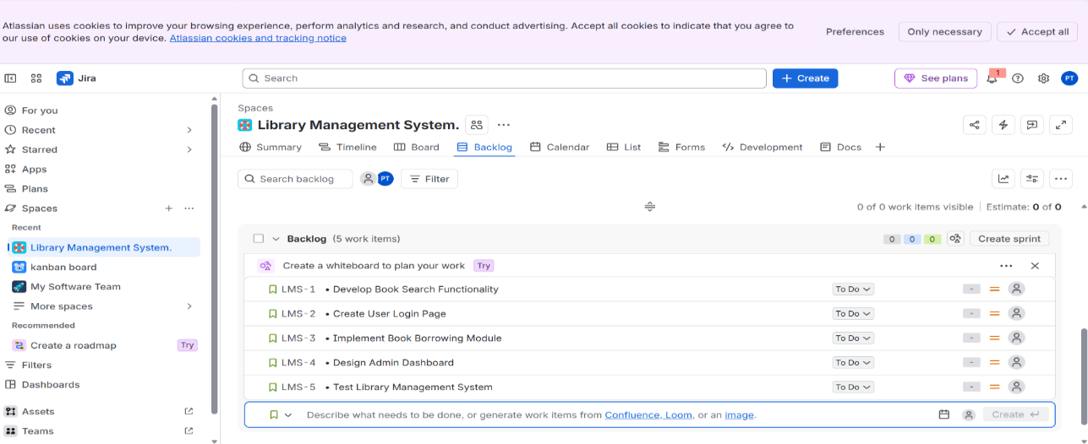
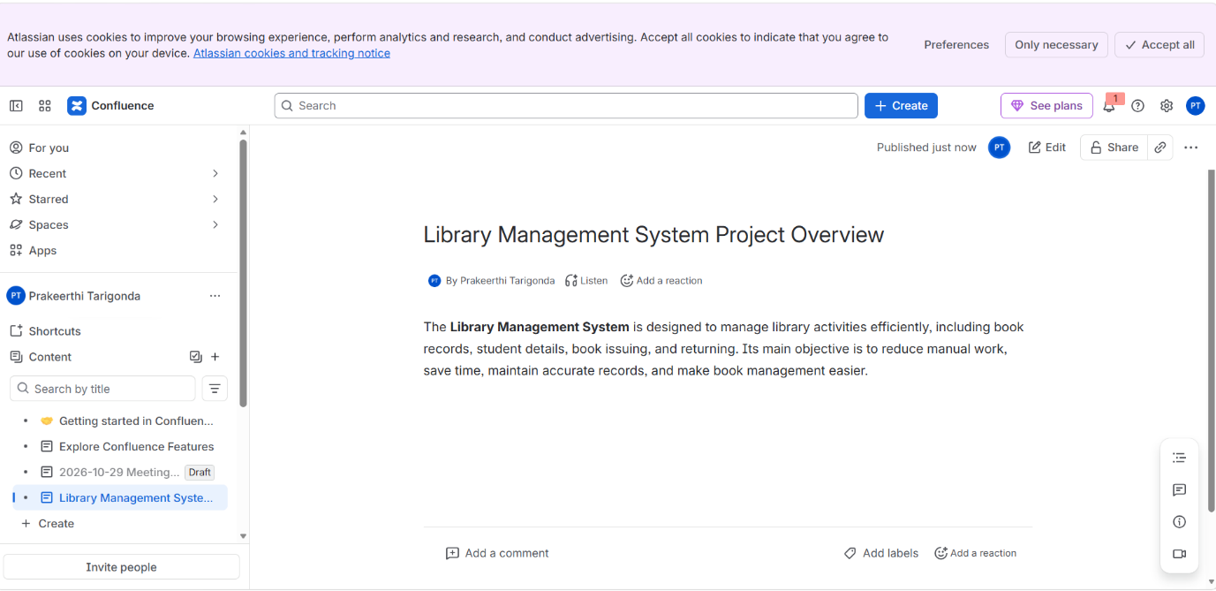
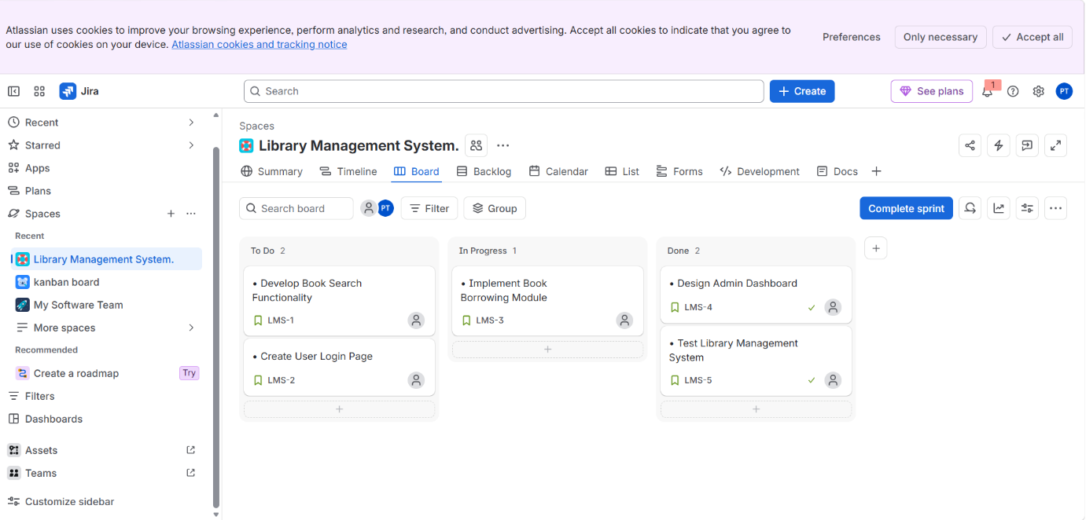
RESULT
Thus, Jira tasks were linked with Confluence successfully. The five Library Management System tasks were displayed with their respective statuses, and a progress bar was added to monitor project completion. This integration helps improve task tracking, progress monitoring, and team collaboration.

